

DEPARTMENT OF COMPUTER SCIENCE
WITH ARTIFICIAL INTELLIGENCE

IBM PROJECT
SILVER PRICES PREDICTION USING HISTORICAL MARKET DATA

Submitted by
SALED JERNISHA M (222511548)
MEGALA P (222511543)
MALINI K (222511542)

BACHELOR OF SCIENCE IN COMPUTER
SCIENCE WITH ARTIFICIAL INTELLIGENCE

Under the guidance of
Mr.Kavin Chakaravarthi VM - Corporate Trainer

2025 - 2026

DECLARATION

We,Saled Jernisha.M , Megala.P and Malini.K, hereby declare that this project report on “Silver Prices Prediction Using Historical Market Data” submitted to the University of Madras in partial fulfillment of the requirement for the award of the Degree Bachelor of Computer Science with Artificial Intelligence under the guidance of MRS CAROLIN JOSHIBA.S., HEAD OF DEPARTMENT and Mr.Kavin Chakaravarthi VM has not been submitted earlier to any other university or institute for the award of any degree.

SALED JERNISHA M
MEGALA P
MALINI K

Place: Padur
Date: 03/02/2026

BONAFIDE CERTIFICATE
This is to certify that the project titled “Silver Prices Prediction Using Historical Market Data” is the bonafide work done by, Saled Jernisha.M, Megala.P and Malini.K hereby and First-year student of Jeppiaar College of Arts and Science, Padur, Chennai in partial fulfillment of the requirement for the award of the Degree of Bachelor of Computer Science with Artificial Intelligence 2025-2026.

PROJECT GUIDE: HEAD OF THE DEPARTMENT:
MR.KAVIN CHAKARAVARTHI VM

Date: 03/02/2026

S. No | INDEX | Page No
 | Introduction
 | Abstraction
 | overview
Data Pre-processing

Data Cleaning

Feature Selection
- Date Conversion
Model Training and Prediction
- Machine Learning Algorithms Used
- Training Process
 | Model Evaluation
 | Data Visualization
Methodology

Data Collection
- Feature Selection

Data Splitting

 | Screenshot
 | Conclusion
 | References

1.INTRODUCTION:

Sales and revenue are key indicators of a company’s business performance and financial stability. Studying sales trends and revenue performance helps organizations understand how their products or services perform in the market over time.
Brief explanation with points:
- Sales trends show the pattern of sales growth or decline over a specific period
- Revenue performance indicates the company’s ability to generate income
- Analyzing past sales data helps identify seasonal and market-based changes
- Understanding customer demand improves sales planning and forecasting
- Product-wise and time-wise analysis highlights strong and weak areas
- Sales trend analysis supports better pricing and marketing strategies
- Revenue analysis helps in controlling costs and improving profitability
- The study assists management in making informed, data-driven decisions

Overall,this study provides valiable insights that help businesses improve sales efficiency,increase revenue,and achieve long-term growth.

2.ABSTRACTION:

This study focuses on predicting silver prices using historical market data to support better investment and financial decision-making. The main objective is to analyze past price movements and identify patterns that influence future silver prices.

Key points of the study include:
- Collection of historical silver price data from financial markets
- Analysis of price trends, fluctuations, and volatility over time
- Identification of factors affecting silver prices such as demand, supply, and market conditions
- Application of statistical and machine learning techniques for price prediction

- Comparison of actual prices with predicted values to evaluate accuracy
- Use of performance metrics to assess the prediction model
- Support for investors and analysts in understanding future price movements

The study helps in improving forecasting accuracy and provides valuable insights for investment planning and risk management.

3.OVERVIEW:
Silver is one of the most important precious metals, widely used in industries such as electronics, medicine, jewelry, and investment markets. The price of silver is highly volatile and influenced by several factors including global economic conditions, inflation rates, industrial demand, and market speculation. Due to these fluctuations, accurately predicting silver prices is a challenging task using traditional methods.
With the advancement of Machine Learning (ML), it has become possible to analyze large volumes of historical price data and identify complex patterns that are not easily detected by manual analysis. Machine learning models learn from past silver price trends and market behavior to forecast future prices with improved accuracy.
This project focuses on Silver Price Prediction using Machine Learning techniques. Historical silver price data is collected and preprocessed to remove inconsistencies and extract meaningful features such as opening price, closing price, high price, low price, and trading volume. These features are used to train machine learning models that can predict future silver prices.
The proposed system helps investors, traders, and financial analysts make better investment decisions by providing data-driven price forecasts. It also demonstrates the practical application of machine learning in financial market analysis and commodity price forecasting.

4.DATA PREPROCESSING:
Data preprocessing is the most important step in machine learning to improve model accuracy.

4.1 Data Cleaning
The silver price dataset may contain:
- Missing values
- Incorrect date formats

- Duplicate rows
These issues are removed using Python libraries like Pandas.

4.2 Feature Selection
Important columns used:
Feature | Meaning
Open | Price at market opening
Close | Price at market closing
High | Highest price of day
Low | Lowest price of day
Volume | Trading activity
These features directly influence price movement.

4.3 Date Conversion
The date column is converted into proper datetime format to allow trend analysis and time-series forecasting.
Why preprocessing matters in real world:
Clean data leads to accurate predictions in finance, healthcare, and business analytics.

5.MODEL TRAINING AND PREDICTION:

5.1 Machine Learning Algorithms Used

Linear Regression
- Finds relationship between price features and future price
- Simple and fast
- Best for trend-based prediction

Random Forest Algorithm
- Ensemble method combining many decision trees
- Reduces overfitting
- Handles market volatility better

5.2 Training Process
- Split dataset into:
  - 80% Training data
  - 20% Testing data
- Train model using historical prices
- Generate predictions for future values
Real-world usage:
Stock markets, cryptocurrency forecasting, commodity trading systems

6.MODEL EVALUATION:
To measure prediction accuracy, performance metrics are used:

Mean Squared Error (MSE)
Measures average prediction error.

R-Squared Score
Shows how well the model explains price variation.
Higher R² = Better prediction performance.
Why evaluation is important:
Prevents financial loss by validating prediction reliability.

7. DATA VISUALIZATION:
Graphs are used to understand price trends clearly.

Common Visuals:
✔ Line chart of silver price over years
✔ Predicted vs actual price graph
✔ Trend movement analysis
Visualization helps in:
- Detecting market crashes
- Recognizing upward/downward cycles
- Investment timing decisions

8.METHODOLOGY:
The methodology describes the systematic approach followed to predict silver prices using machine learning techniques. The complete process consists of data collection, preprocessing, model training, evaluation, and prediction.

1. Data Collection
Historical silver price data is collected from reliable financial sources such as commodity market databases or online datasets. The dataset includes attributes like date, opening price, closing price, highest price, lowest price, and trading volume.
This historical data serves as the foundation for training machine learning models.

2. Feature Selection
Important features such as open price, close price, high price, low price, and volume are selected as input variables. These features directly affect silver price movement and improve prediction accuracy.
Irrelevant columns are excluded to reduce complexity and overfitting.

3.Data Splitting
The dataset is divided into two parts:
- Training Data (80%) – used to train the machine learning models.
- Testing Data (20%) – used to evaluate model performance.
This split helps in validating the prediction capability of the model on unseen data

9.SCREENSHOT:

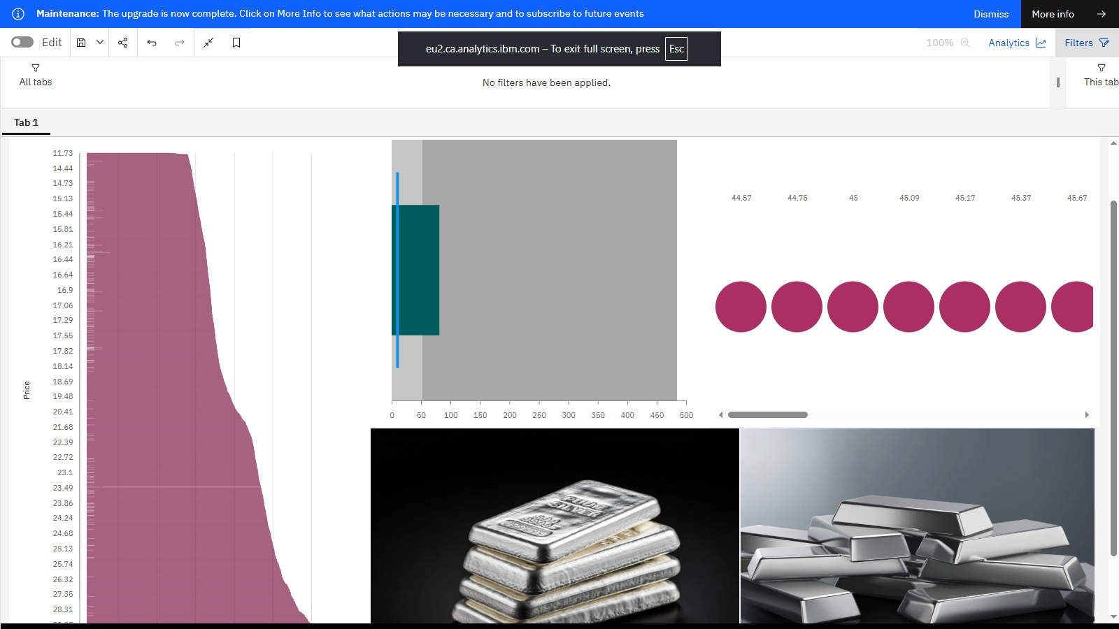

10.CONCLUSION:
This project successfully demonstrates how machine learning can predict silver prices using historical market data. The models identified important price patterns and produced accurate future estimates.
Machine learning offers a powerful tool for financial forecasting and investment planning. With more features such as global economic indicators and demand trends, prediction accuracy can be further improved.
Future Scope:
- Deep Learning (LSTM models)
- Real-time price prediction
- Multi-commodity forecasting systems

11. REFERENCES:

- click here to dataset

click here to git

